Melanie Pierce

November 29, 2016

Characterization of Keithley Rates for Uncertainty in FW50 values

*Goal:*

To characterize the signal to noise ratio for each of the distinct speed settings on the Keithley 6487 picoammeter. This study will determine the most efficient rate at which to measure the current accounting for speed and signal clarity. We will characterize the best combination of settings to give us the lowest possible uncertainty in the emittance measurements. These factors include the “speed” of the picoammeter, the number of samples acquired at each (slit one, slit two) position, the spacing between the slit two positions at each slit one position, the range of travel of slit two per slit one position, and the number of slit one positions.

*Theory:*

The noise detected in the measurements can arise from several different origins, one being the source of the measurement, or vibrations from the surroundings or from the type and length of cable used to connect the source to the picoammeter. What we can work on correcting is raising the airtable so vibrations have less of an impact and using the shortest possible cable between the chamber and the Keithley. While these changes have offered some improvement, there is still the issue of noise being present from the Keithley itself. The intensity of the interference from within the Keithley increases the faster the data is being gathered. As an example, choosing the FAST setting causes an overload on the 2nA setting when we should be expected to get ~2.5pA or 0.002nA.

Selecting the rate selects the integration time (period of time the input signal is measured) of the A/D converter within the Keithley 6487. The integration time affects the amount of reading noise, as well as the ultimate reading rate of the instrument. The rate is measured in PLCs (power line cycles) where 1 PLC for 60Hz is 16.67msec and 1 PLC for 50Hz is 20msec. The 6487 is optimized for the 1 to 10 PLCs reading rates. At these rates the 6487 with make corrections for its own internal drift and still be fast enough to settle a step response < 100ms.1

We have already ruled out the FAST rate for the emittance scanner, but there are ranges within MED and SLOW that should be investigated. The medium integration time is 1 PLC, whereas the slow integration time is 6 PLC for 60Hz and 5 PLC for 50Hz. We looked closely at the speeds near MED and recorded 100 current measurements at 21 different slit two positions for one, two and three power line cycles.

*Data:*To gather the data, I essentially performed an emittance scan at one slit one position but recorded multiple current readings at each slit two position. My first data set was comparing the three main speeds on the Keithley being FAST, MED and SLOW. FAST was ruled out quickly because it would require the Keithley be in auto-range mode, which would cost us time and precision. The current readings being gathered should be in the single picoamps, so auto-range would not be necessary anyway. The Keithley would require more time to gather measurements due to constantly switching ranges, and this would produce less accurate data points with fewer decimal places. We are already on the lowest possible range setting and the display on the Keithley can only display picoamps to the second decimal place.

After ruling out the FAST setting, I produced a box plot of the MED and SLOW settings seen below. I moved slit two 30 times to produce 31 different locations and read 50 current readings at each point.

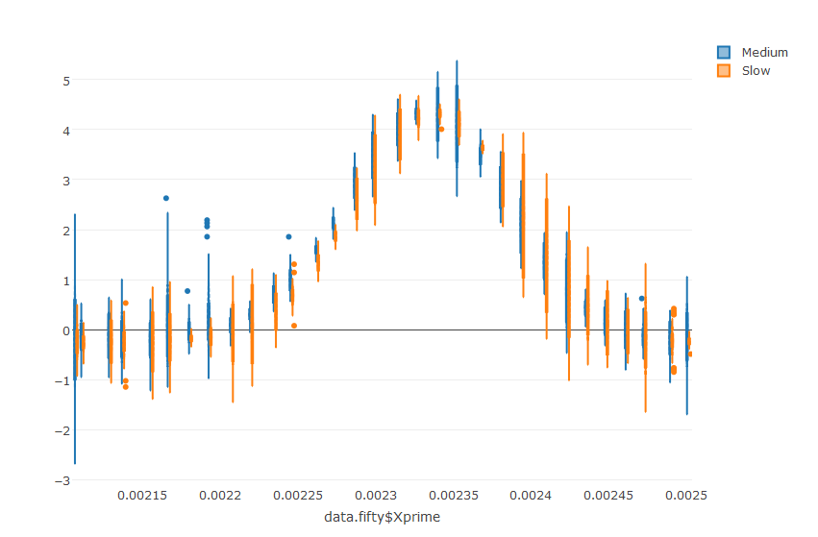

Figure : Box plot of the Medium(16.67ms integration time) and Slow(100ms integration time) rates for the Keithley 6487. 50 data points were measured at 31 positions in xPrime.

I observed minimal difference between MED and SLOW so I chose to look at smaller integration times and looking at One, Two, and Three PLCs. This choice was made due because there was not a significant enough improvement in the distribution to warrant a 6 times slower rate. The optimal scan rate will be fast as well as precise. I chose instead to do 100 readings per point for 20 points. The number of points was chosen to allow for a larger sample size when resampling the data to find the uncertainty in the FW50 values. The number of points was chosen to prevent repeated readings. The stage motor’s accuracy in movement is restricted by ±2 microns. With 31 steps in the prior sampling the stage was requested to move 5 microns, but was really only move approximately 2 microns. Smaller steps than that could cause the motors to not move at all. I chose fewer number of steps in order to take larger step sizes and reduce the possibility of creating duplicate steps. Twenty steps equates to 8 micron moves at each interval.

*Finding Variance in Data Set:*

After completing the scans, I read them into Rstudio and ran a resampling script. From 1 to 30 data points from each location, the script averages the points and sends them to a python script which computes the FW50 of the data and sends it back to R to store in a list. For each point, this is done 350 times. After that is completed, for each sample size I have a list of 350 full width fifty values. The half width of the confidence is found by finding the standard deviation of the values and multiplying by 1.96 to find the 95% confidence level. For each set ( One, Two and Three PLCs) I plotted the low bound ( mean – confidence), the estimate (mean) and the high bound ( mean + confidence) and produced the three plots below. The high and low bounds make up the range in which I am 95% confident the true value is within.

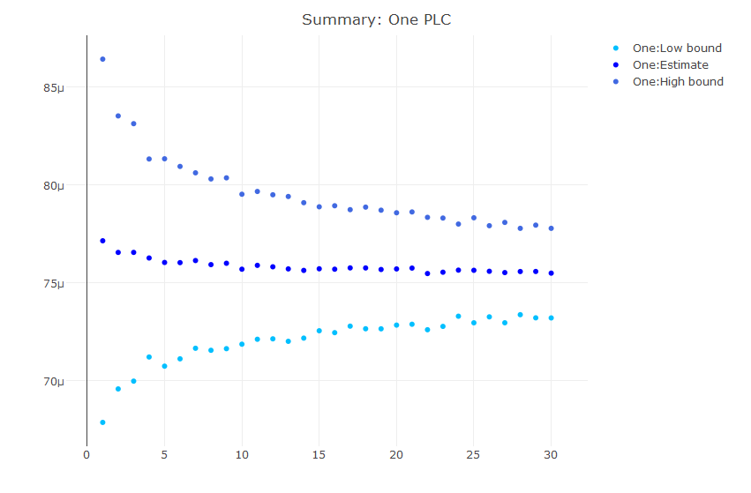

Figure : Plot of the FW50 values versus the number of data points sampled for the high bound, low bound and the estimate. For each point, we are 95% confident the value will be within the high and low bounds.

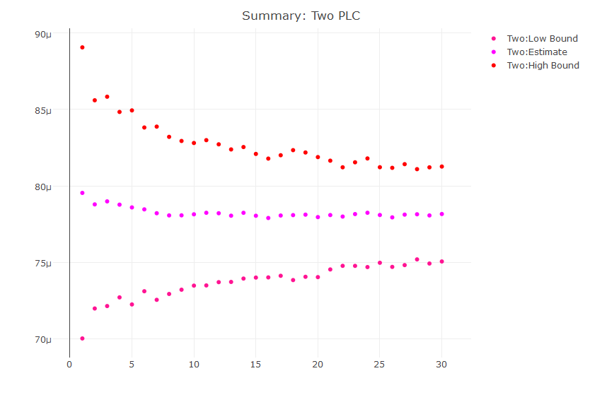

Figure : FW50 values versus number of data points sampled for the high bound, low bound and estimated value.

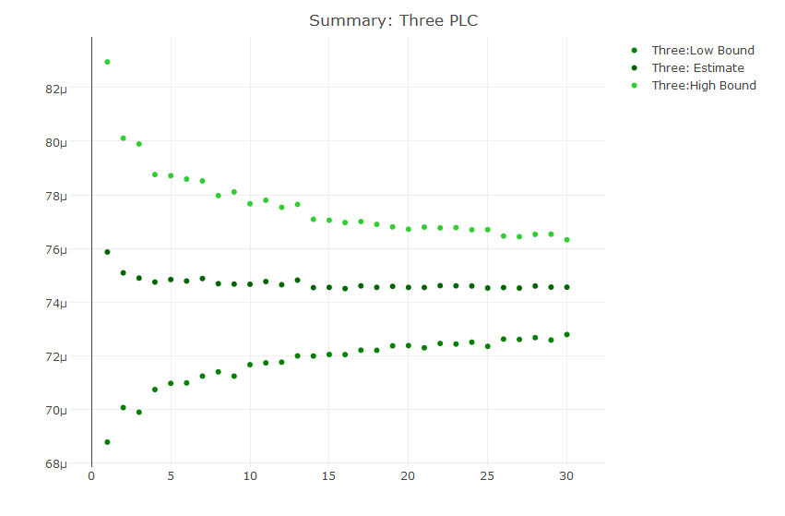

Figure : FW50 values versus number of data points sampled for the high bound, low bound and estimate value.

From the three sets of data I can see that as the number of data points sampled grows my confidence range is smaller. As I average more data points, I get a better idea of what the real value is, and begin to approach that value. Now that I can see how the confidence interval becomes smaller over more samples, I want to compare the data to each other to determine which rate will produce the smallest confidence range. The end goal of this study is to understand what integration time for the Keithley 6487 will produce the “best” results – defining best as lowest uncertainty in the measurements. Out of these measurements, the chosen rate will display a fast stabilization as the number of points increases, as well as a small distribution. This means that our data is precise and that less averaging needs to be performed thus giving us the proper ratio of speed to precision.

Initially I plotted all three sets on the same axis to observe how the data fit with each other as seen in Figure 5. This did not work too well as the graph was too muddle, and it became hard to see what was really occurring it was expected that the three difference measurements would share similar estimates as well as starting and ending points for the high and low bounds. This would have allowed me to observe how quickly the bounds begin to flatten out and select which of the three reached a stable point quickest. This however was not the case, which makes it difficult to view the data. The One and Three PLC data sets were relatively similar, but the Two PLC set was at least three times farther away from the other two sets in all three regards. 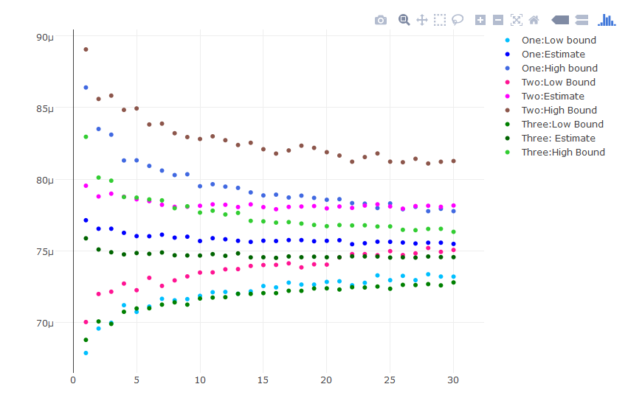

Figure : Plots of one, two and three power line cycles with their high, low bounds and estimates.

To get a better sense of the change in the variance over number of data points sampled, I then plotted just the difference between the high and low bounds to observe if any of the sets have a significantly smaller distribution. I also calculated how long it took to measure the data points by multiplying the number of current readings by the time it takes to read one value at that rate and the number of positions moved to. This will better show how the rates are different in time, and how quickly the rates approach a stable point.

*Stabilization over Time:*

The next step was to understand how quickly the data points are read from the Keithley and into the file. The chosen rate should be precise as well as quick to extend the lifetime of the slits as long as possible. I measured the time it took to read 100 points and wrote them to the file at every cycle in the four loop. I performed this for the one, two, three and six PLC settings. I then repeated the test for the Three PLC but instead saving the values to an array rather than write to a file to see if that action added a significant increase to the time. The data was collected in the table below. I observed that the time did not increase linearly, which was expected due to the integration time increasing linearly. Writing the data to a file as opposed to an array only added an extra millisecond per measurement, which was consistent in both the one PLC and three PLC rates (only the 3 PLC rate is in the table). I took these times and computed the time per measurement. I then multiplied that by the number of readings in our resampling and the number of stops taken. I can now observe how the variance decreases the longer the scan took.

|  |  |  |  |  |
| --- | --- | --- | --- | --- |
| 1 PLC | 2 PLC | 3 PLC | 3 PLC to Array | 6 PLC |
| 7.671 | 12.69 | 17.688 | 17.56 | 32.676 |
| 7.667 | 12.702 | 17.711 | 17.556 | 32.7 |
| 7.6758 | 12.7 | 17.669 | 17.558 | 32.679 |
| 7.666 | 12.701 | 17.674 |  | 32.687 |
| 7.683 | 12.694 | 17.714 |  | 32.662 |
| 7.668 | 12.687 | 17.675 |  | 32.685 |
| 7.664 | 12.679 | 17.669 |  | 32.68 |
| 7.664 | 12.697 | 17.669 |  | 32.669 |
| 7.665 | 12.686 | 17.673 |  | 32.673 |
| 7.665 | 12.698 | 17.67 |  | 32.665 |
| 7.667 | 12.683 | 17.664 |  | 32.675 |

Table : Lists the time to record 100 measurements for a scan with 10 stops. The 3PLC to array was a test to see how much of a time impact writing to a file inside the loop took.

First I took the graph of all three rates each with their own bounds and estimate and made it time dependent as explained at the end of the previous section. I plotted the high, low and estimates for each again in Figure 6, but this time with the time dependence.

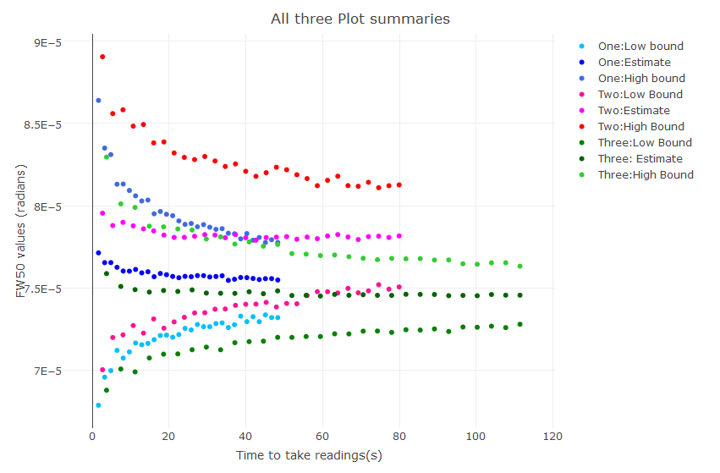

Figure 6: Plot of the FW50 high and low bounds and the estimates for one, two and three PLC based on the length of time in seconds to complete the scans.

After looking at the data in this fashion, it is easier to see how the data stabilizes the slower it took, but surprisingly, it appears that the one and three PLC data sets are not significantly different. The three PLC does achieve a smaller variance after almost 2 minutes, but the one PLC appears to be stabilizing at the same rate at the three PLC. I next chose to look at the variance, but instead of values of FW50, I wanted to know how far off of the ideal value the data was in time. To do this, I took the half range (high bound – ideal) and divided by the ideal value and multiplied by 100 to make it a percentage. When I say the ideal, what I am referring to is the value for the FW50 that the data is approaching. As time increases out to infinity, the bounds get smaller and smaller as they approach the value. For the purposes of this data set, I chose the last value of the estimate as it is the ideal value the boundaries approach.

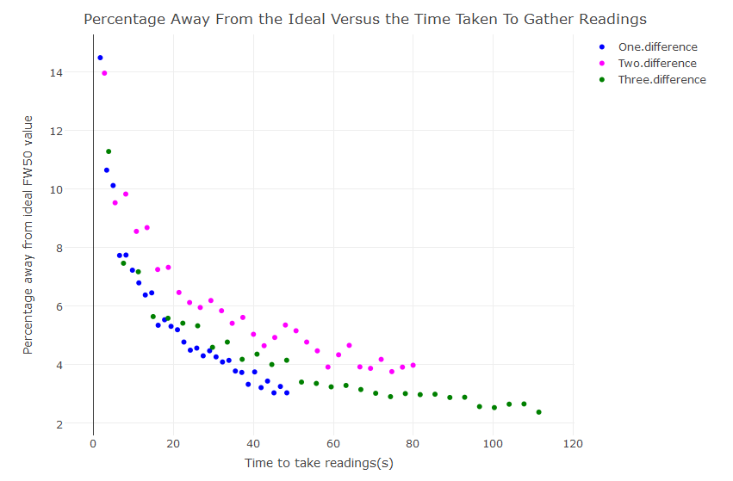

Figure 7: Plot of percentage away from the ideal FW50 over the time to take the values.

Observing Figure 7 brings me to the same conclusions as the previous figure, in that the spread for one and two PLC’s is remarkably similar. It does not appear that there would be a significant drop in precision of the data if one PLC was chosen over three. I ran the data a second time to see if these results are replicable. 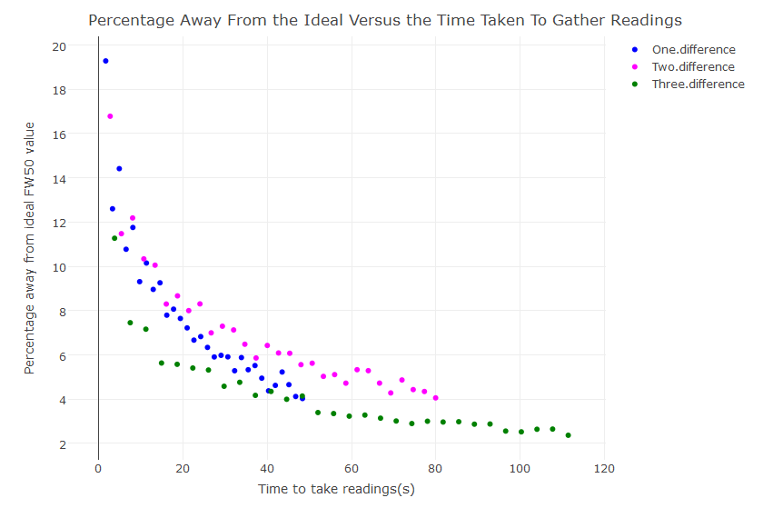

Figure 8: Percentage from ideal versus time taken to gather readings for the second set of data points which was also 21 stops with 100 points each.

The second set of data also shows a very similar trend in the 2 PLC dataset as seen in figure 8. It should be performing better than the one PLC in that it should be approaching 0% at a faster rate than the one PLC, and should end at a lower percent than the one PLC. Both characteristics are not true. The second set of data does not perform as expected with the three PLC dataset. The percentage decreases at a faster rate and the data continues to drop as the time increases. While the three PLC should perform better than the two PLC and the one PLC, the two PLC should not be the worse of the bunch.

As a quick sanity check to test if slower data performs better in general, I perform the same resampling, but for the initial set of data between the slow and medium. Because I had a smaller sample size per stop I did resampling from 1 to 15 points 150 times for 31 stops. The medium behaves similarly to the previous plots based on its starting point, ending point, and the slope, but the slow does not behave as expected. In general, the slow rate should have the best signal clarity and while it takes longer, it should drop to a smaller percentage away from zero. This is due to taking a longer amount of time to process the data, so there is less internal noise added to the signal.

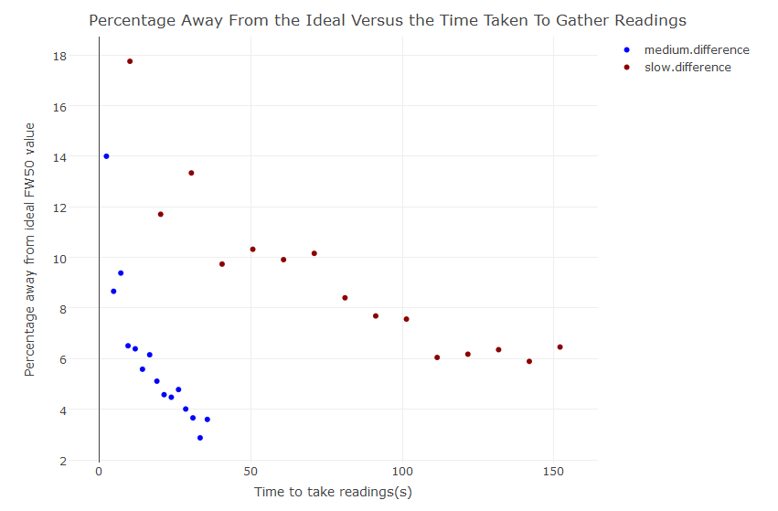

Figure : Percentage away from ideal value versus time for the medium (1 PLC) and slow (6 PLC) rate presets.

In Figure 9, I can see that neither assumption is true. The medium rate drops much faster and reaches a smaller percentage than the slow rate ever does. Taking this information, I now suspect it has something to do with even vs odd number of power line cycles as I have only observed this behavior for two and six power line cycles. I went back into the lab and repeated the 21 stops with 100 points for 2, 3, 4, 5 and 6 PLCs. Based on the data that even numbers have decreased performance I should see 3 and 5 both perform better than 2, 4, and 6 PLCs.

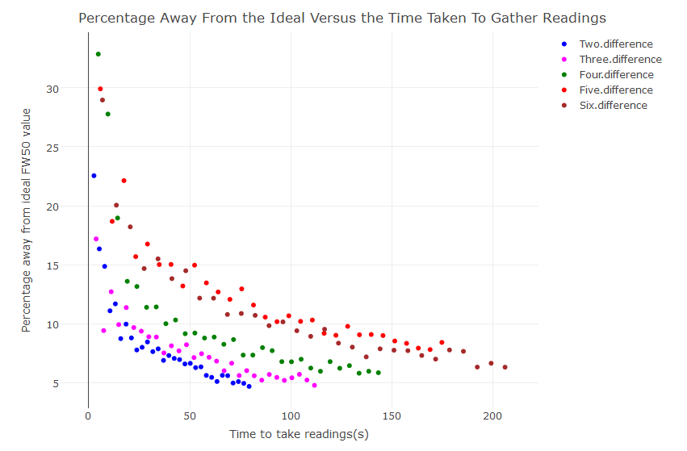

Figure 10: Plot of the percentage away from the ideal value for two, three, four, five and six PLCs. Expected to see better performance (faster drop and lower end value) for the odd numbered sets.

The data taken for the two through six PLC rates did not perform as expected, but instead there is a steady trend of poorer performance as the number of PLCs increases. While the initial drop from the first to the last point is larger for the slower rates it also starts at a higher percentage and as time increases the slower rates don’t perform as well. A longer time to take the reading means it should take less resampling to produce better results. This means that the end value for the slower rates should be lower than the faster rates, which also seems to be incorrect.

My hypothesis that the even numbers would perform better proved to be false as well as the assumption from the Keithley 6487 manual that the slower rates provide better results is also false. Some causes of this could be due to the sensitivity of the system to vibrations. It could have been that the data is inherently poor due to excess vibrations. Figure 10 could be meaningless if the data is not reproducible in a more stable environment. Despite these incorrect theories, the Three PLC rate is performing the best. I had taken the three PLC rate several times over the course of this investigation, so I decided to look at how they stack up against each other.

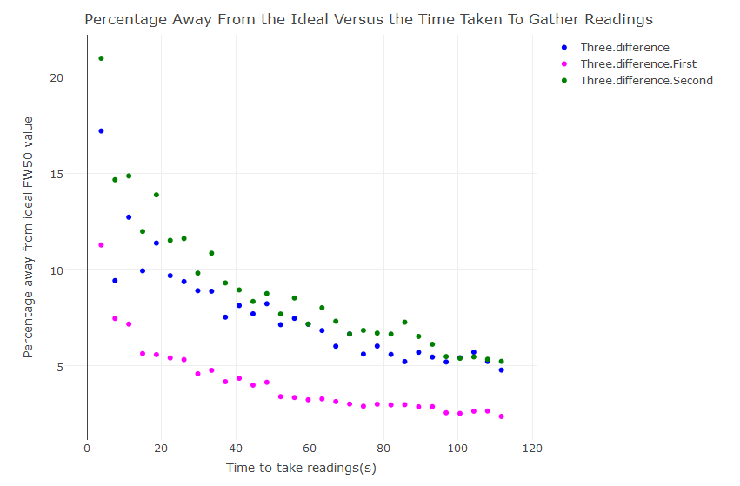

Figure 11: Difference percentage for the three different sets of Three PLCs that I had taken over the course of the experiment. The first set was a very strong set of data, but the second and third are very similar in behavior.

Looking at the three sets together, it appears that the first data set I took was a very accurate set compared to the normal behavior. The last two sets I took decreased at a similar rate and ended near the same place less than 5% away from the ideal FW50 value. I will repeat this experiment after installing new slits and more accurate motion as well as more sets of data to double check that the percentage away is the same as well as the accuracy of the data across multiple data sets.

As a final test, I performed bootstrapping on the most recent set of Three PLC data where I sampled with replacement 100 points at each location and repeated for 1000 times. This produced a box plot of the 1000 means of each current reading at each point and I was able to find the percent uncertainty of half of the confidence interval for the 1000 FW50 values calculated using this method. Figure 12 displays the distribution of the mean current value for each position in the scan. There are 1000 readings that make up each box. Figure 13 is a box and whisker plot of the FW50 values that the 1000 scans produced. From the FW50 values I calculated a confidence interval of 2.88243e-06 and a mean FW50 value of 8.69331e-05. From these two values I calculated a percent uncertainty of 3.31%. This is closer than the resampling alone provided, but is still 1.3% above the allowed uncertainty of 2.0%. There is still more to understand about the best way to gather the data and how to achieve a lower uncertainty, but presently, I can reach some conclusions about the rate to read the data.

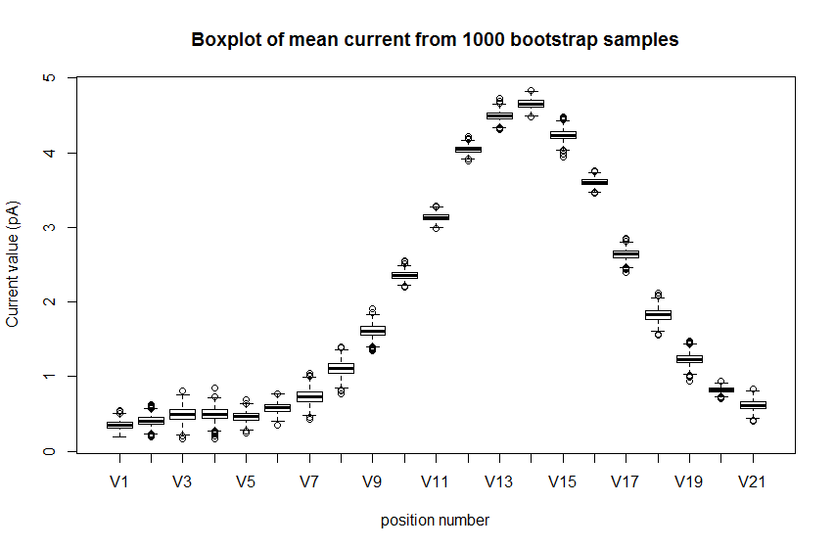

Figure 12: Box plots of the mean current value at every point in the scan after bootstrapping. The bootstrapping was then repeated 1000 times.

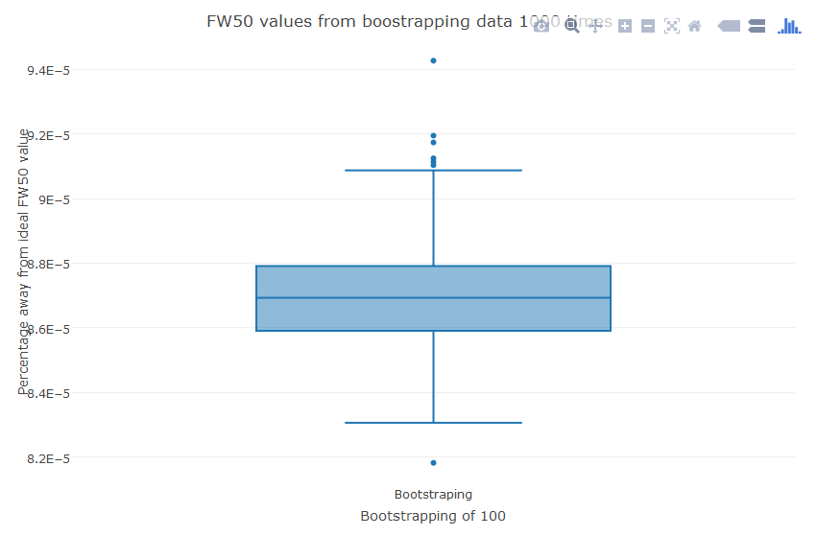

Figure 13: Box and whisker plot of the 1000 FW50 values that were calculated from the previous plot.

*Conclusions:*

After a thorough analysis of all the integer rates from one to six power line cycles, I can conclude that a faster rate is better for our experiment and does not detract from the quality of the readings. The slower rates performed significantly worse in both the decreasing of percentage over time and the final percentage point away from the ideal value. By examining the faster rates I can also conclude that three PLCs is the best rate to be at for smallest final percentage and fastest drop to that final percentage. After plotting just the three PLC sets taken, I observed stability in the data with the only outlier data set being an improvement on the normal set. At this time, the uncertainty in the d50 width data is twice as large as allowed, which could be causing a decrease in brightness and emittance calculations, but several other factors could be contributing to that decrease as well. It is also unclear if the uncertainty is actually twice the allowed uncertainty or if the presented data is a result of not completing a full scan. By utilizing the bootstrap method and iterating 1000 times, I was able to observe a lower uncertainty which is likely to be a better representation of the data as opposed to 30 data points randomly selected from the 100 at each point. By pulling from all 100 points and repeating the sampling more times than before it is more likely that every data point is use several times.

Despite still having concerns about the behavior of the data, and the distribution of the data at each rate, I can safely say that three PLCs is a good choice for the integration rate on the Keithley. There is a low percent uncertainty as well as a relatively quick collection time that can help prolong the life of the slits.